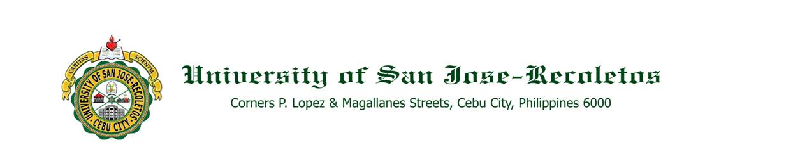

**OFFICE OF THE PRESIDENT**

**TO : ALL JOSENIANS September 1, 2020**

**SUBJECT : MASS IN HONOR OF THE HOLY SPIRIT**

Welcome to USJ-R!

To appropriately start the Academic Year 2020-2021, we shall have our **HOLY MASS in honor of the HOLY SPIRIT** on **September 11, Friday, at 10:00 a.m.,** with ***BISHOP MIDYPHIL B. BILLONES, D.D.,*** Auxiliary Bishop of Cebu, as Main Presider.

The Holy Mass will be broadcasted live via the **USJ-R FB Page @** [**https://web.facebook.com/univ.san.jose.recoletos**](https://web.facebook.com/univ.san.jose.recoletos) (control plus click to follow the link).

**We enjoin all administrators, faculty members, staff and students to attend our ONLINE MASS in honor of the Holy Spirit. Be counted and be part of this celebration!**

Please take note that after the homily, the faculty members will have their profession of faith and oath, a commitment to adhere to the Catholic Faith and its ideals and to teach the Catholic doctrines to our students.

We look forward to your participation as we journey together for the achievement of the University’s Vision, Mission and Goals in spite of the pandemic we are presently challenged.

Let us pray for the healing of all! Adelante!

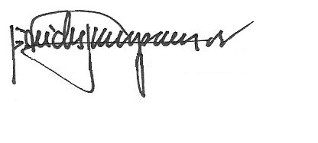

REV. FR. CRISTOPHER C. MASPARA, OAR

President

/bvs